Title:
ED-FEED: An AI-Driven Intelligent Student Feedback Analysis and Insight Generation System

Baseline Model Evaluation:
As a member of the evaluation team, my primary responsibility was to evaluate the baseline sentiment analysis model and understand how effectively it performs on student feedback data. This evaluation played a crucial role in identifying the strengths and limitations of the initial model, which serves as the foundation for further improvements in the system.
To begin with, I focused on setting up the evaluation environment. I successfully loaded the pre-trained Logistic Regression model along with the TF-IDF vectorizer. It was important to ensure that the same preprocessing steps used during training were preserved during evaluation. This consistency guarantees that the model receives input data in the same format, thereby producing reliable and accurate results.
Following the model setup, I worked on validating the dataset used for evaluation. The dataset consisted of approximately 35,421 student feedback responses. I carefully inspected the dataset to confirm its integrity and usability. This involved checking for missing values, verifying column structures, and ensuring that the data was clean and properly formatted. By doing this, I ensured that the evaluation process would not be negatively impacted by incomplete or inconsistent data.
Once the dataset was verified, I moved on to the preprocessing stage. Since machine learning models cannot directly interpret textual data, I used the TF-IDF (Term Frequency–Inverse Document Frequency) technique to convert the textual feedback into numerical feature vectors. This transformation allowed the model to capture the importance of words within the dataset and identify meaningful patterns in student feedback.
After preparing the data, I proceeded with running the model on the dataset. The Logistic Regression model analyzed each feedback entry and predicted its sentiment category, classifying it into labels such as positive, negative, or neutral. Once the predictions were generated, I compared them with the actual sentiment labels present in the dataset to measure the model’s performance.
Based on this evaluation, I observed that the model achieved an overall accuracy of approximately 75–76%. One notable observation was that the model performed particularly well in identifying negative feedback. This is especially valuable, as detecting negative sentiment helps in identifying areas of concern or dissatisfaction among students. However, the model showed relatively lower performance in distinguishing between neutral and positive feedback, indicating some limitations in capturing subtle differences in sentiment.
In addition to accuracy, I also analyzed the behavior of the model in different scenarios. I found that the model performs effectively when dealing with simple and straightforward sentences where sentiment is clearly expressed. However, it struggles when handling complex sentences, sarcasm, or context-dependent feedback. This limitation arises because Logistic Regression, combined with TF-IDF, primarily relies on word frequency and does not fully understand the semantic meaning or contextual relationships within the text.
Through this evaluation process, I gained a comprehensive understanding of the baseline model’s capabilities. The model is lightweight, fast, and computationally efficient, making it a good starting point for sentiment analysis tasks. At the same time, its inability to capture deeper linguistic context highlights the need for more advanced models, such as transformer-based approaches, in future improvements.
Overall, my contribution involved setting up the evaluation pipeline, validating and preprocessing the dataset, executing the model, analyzing its performance, and identifying key areas for enhancement. This evaluation provided valuable insights into how the baseline model performs in real-world scenarios and helped establish a strong foundation for building more advanced and accurate sentiment analysis systems in the ED-FEED project.

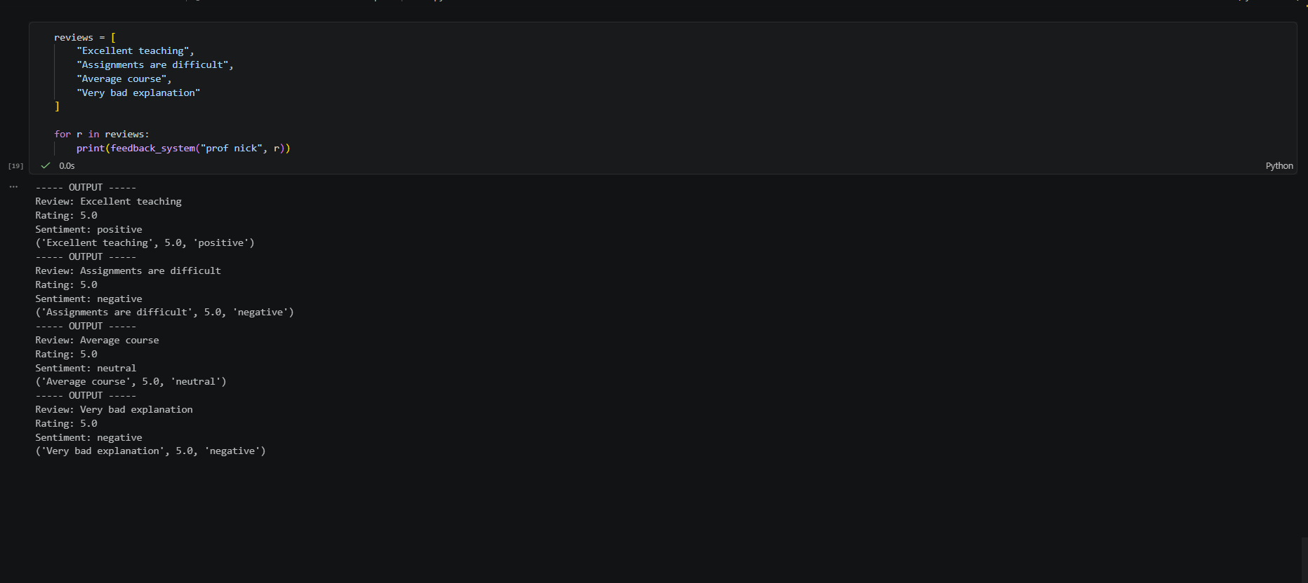

Review Text | Predicted Rating | Predicted Sentiment
Excellent teaching | 5.0 | Positive
Assignments are difficult | 5.0 | Negative
Average course | 5.0 | Neutral
Very bad explanation | 5.0 | Negative

